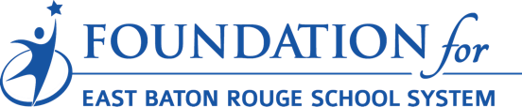

Foundation for East Baton Rouge School System ExxonMobil STEM Innovation Grants
Application Instructions - July 2018

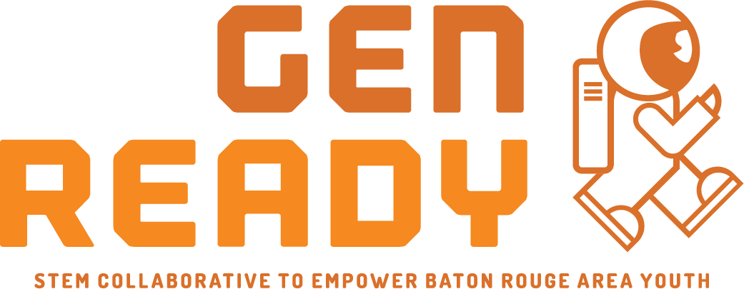
The Foundation for East Baton Rouge School System is seeking proposals from educators in elementary, middle and high schools in East Baton Rouge Parish School System to implement high-quality, innovative STEM programs. Proposed projects should align with the GEN READY/BR STEM Network vision, mission and goals.
ABOUT GEN READY
The Foundation for East Baton Rouge School System established the BR STEM NETWORK in 2016 through initial funding from ExxonMobil. In 2018 the BR STEM Network was renamed as GEN READY. The network was renamed to focus on the collaborative network objective of preparing our next GENeration of young people for success; to make them college and job READY. The goals remain the same, to increase the number of students graduating from high school possessing requisite STEM skills and knowledge to be post-secondary education-ready and to be competitive for the 21st century workplace.
GEN READY GOALS:
1. Future Ready Students- Increase student interest, participation and achievement in STEM
2. Effective Educators- Increase number of effective STEM educators in all settings.
3. Informed Community- Increase engagement of post-secondary and business community
4. Engaged Partners- Increase broad family and community support for STEM education as a priority in BR
APPLICATION GUIDELINES:
Please read carefully to fully understand guidelines and expectations.
Funding to support projects in classrooms, across grade levels or even school-wide is available through a generous grant from ExxonMobil. Grants will be made available to classroom teachers or to schools. Grant awards may range from $250-$10,000 per project. Projects must be innovative and have potential for replication in other schools in East Baton Rouge Parish School System. Projects should focus on increasing student interest and engagement in STEM.
These STEM grants provide funding for projects in EBR schools that foster STEM experiences for students. Additionally, the grants allow for the development and documentation of best practices in order to support STEM engagement across the district. Projects must include components to enhance student experience, teacher development, best practice development and sharing, and/or workforce alignment with measurable goals.
GRANT AWARDS:
Grant awards will be made available for up to $10,000. Grants of $10,000 are limited and require significant project design and development. Most grant awards will be for projects less than $5,000.
All funds are reimbursable and require documentation of expenses before payments will be made. Teachers must adhere to school and district level policies for all expenses. All requests for reimbursements should be made no later than May 15, 2019. All donated funds should be spent on expenses for items on the approved project budget. The Foundation for EBRSS will provide all grant recipients with a reimbursement form to request payment for expenses incurred. With pre-approval the Foundation can make payments to vendors directly. Principal approval is required for all projects and purchases. Payment for reimbursement is approximately 7-10 days after fully completed reimbursement form is submitted to the Foundation for EBRSS office.
APPLICATION DEADLINE:
Applications must be completed by July 31 at noon.
NOTIFICATION OF RECIPIENTS:
Recipients will be notified approximately 6-8 weeks from submission deadline.
Documentation and evaluation will be required of all grant recipients.

DIRECTIONS: No grant applications should be delivered to Foundation EBRSS office or sent via email or mail. This document is provided to assist you in preparation of your application. Final applications will be collected via online submission. It is suggested that you answer all questions in a word document and copy your answers into online form. Save your word document for reference.
Link to grant: https://www.surveymonkey.com/r/EMSTEM2018

Project Title: _______________________________________________________

Grade Level(s): ________________ Subject: _____________________________

Project Implementation Dates: ____________________ to __________________
(begin) (end)

Total Amount of Request: _____________________________

GRANT NARRATIVE: Do not include school or teacher name in narrative section of your application.

- Briefly describe the project and the need for it.
- Provide a brief narrative overview of your project that aligns with the vision, goals and strategies of the GEN READY Collaborative?
- How will the project provide an inspirational STEM experience for students?
- What is innovative about the project design?
- What will you measure to show success? How will you evaluate whether your objectives have been achieved? (A written project evaluation is required at the completion of the project).
- How will volunteers be used to support project implementation?
- How will grant funds be used? Please provide specifics?
- What is the project budget? Please upload (to survey monkey application) a detailed budget request including specific information on materials and equipment needed. Include information about sources of materials, duplicating costs, estimated fees, shipping charges and other miscellaneous expenses. Include project title on budget document. What other sources of funding do you have for this project?
- How will you modify your proposed project design should you receive less than the requested amount of funding? Is full funding required for a successful project?
- How many students will be directly involved in the project in 2018-19 school year? What is the potential for expansion of this project to other grade levels, classes and/or schools?
- Provide an outline of project implementation timeline. Include planning and evaluation. List a chronological time schedule which includes, as applicable: completed lesson plans, ordering/receipt of materials, actual classroom implementation, evaluation, and any other significant dates.

